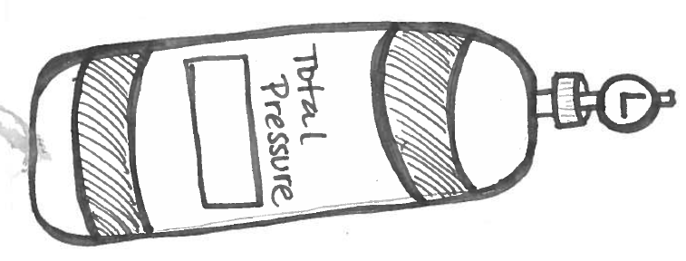
P_{T}= 760mmHg + 34mmHg + 1000mmHg
P_{T}= 1794 mmHg

P_{T}= 8.39 atm + 23.43 atm + 12 atm + 3 atm = P_{T} =46.82 atm
920 kPa= 89 kPa + 99 kPa+ 350 kPa + P₄
P₄ = 382 kPa
5323mmHg= 1984 mmHg+ 1977mmHg+ P₃
P₃ = 1362 mmHg
P_{T} | P₂ | P₂ | P₃ | P₄
3029kPa | 323kPa | 1939kPa | 745kPa | 22 kPa
19.78 atm | 7atm | 2.3 atm | 10 atm | .48atm

I have a flask with three gases inside: oxygen, nitrogen, and helium. The oxygen has a partial pressure of 0.23 atm, while the nitrogen exerts a pressure of 0.64 atm, and the helium exerts 0.09 atm of pressure. What is the total pressure in the flask?
P_{T} = 0.23 atm + 0.64 atm + 0.09 atm
P_{T} = 0.96 atm
A basketball is pumped with air. The total pressure of the ball is 8.2 kPa. I know that several gases are in the ball. Oxygen exerts 2.15 kPa, nitrogen exerts 4.34 kPa, and hydrogen exerts 0.78 kPa. If the other gas in the ball is helium, how much pressure does the helium exert?
8.2 kPa= 2.15 kPa + 4.34 kPa+ 0.78 kPa + P_{helium}
P_{helium} = 0.93 kPa

Add up all of your answers, ask your teacher to check the final answer.

